Lent 2024

Seeking God
The
Creator

Welcome to the 2024 Lent Course
‘Seeking God the Creator’

During this Lent, we are invited to meet six times, to consider reflections based upon the Collect for Ash Wednesday:
a
lmighty and everlasting God,
you hate nothing that you have made
and forgive the sins of all those who are penitent:
create and make in us new and contrite hearts
that we, worthily lamenting our sins
and acknowledging our wretchedness,
may receive from you, the God of all mercy,
perfect remission and forgiveness;
through Jesus Christ your Son our Lord,
who is alive and reigns with you,
in the unity of the Holy Spirit,
one God, now and for ever. Amen

You are invited to follow the material offered. You will be encouraged to enter in the exercise of lectio divina (sacred reading) using one of the texts from the Sundays of Lent. The questions posed are for guidance and serve as way-markers; they are not intended to be a burden, to set an agenda, or to form that basis of a test.

Always go where called!

May I wish you a holy Lent, and one where you can encounter your Creator in your daily lives.

Fr David Cloake

Week 1: … you hate nothing that you have made …

The Gathering
Leader Your Church makes glad in you, oh Christ, and cries aloud: You are our strength, O Lord, our refuge and our stronghold
All You are our strength, O Lord, our refuge and our stronghold
Leader Seeing you lifted upon the Cross, O Sun of righteousness, the Church stood still and cried aloud: Glory to your power, O Lord
All Glory to your power, O Lord
Silence is kept
Leader The Lord God almighty is our Creator.
All he loves us and tenderly cares for us.

Conversation Question
- What, if anything, have we done to approach Lent differently this year? Have you given up something or adopted a new thing? Why did you make that choice, or choose not to?

God’s Word in Sacred Reading
- Read the following passage from Luke’s Gospel silently, giving yourself permission to be present as an eyewitness in the scene
- In your mind, examine the environment that gives the reading its setting – the temperature of the desert, the feel of the ground beneath your feet, the smells etc.
- Note how this environment makes you feel
- One person from the group reads the passage aloud. Note a word or phrase that persists in your thoughts or catches your attention. Don’t question it – just acknowledge it!
- Another voice reads the passage as you ruminate on the word or phrase that caught your imagination. If your mind is called elsewhere, follow.

Ruminate – verb
- think deeply about something.
- (of a ruminant) chew the cud.

Luke 4.1-13
1Jesus, full of the Holy Spirit, returned from the Jordan and was led by the Spirit in the wilderness, 2where for forty days he was tempted by the devil. He ate nothing at all during those days, and when they were over, he was famished. 3The devil said to him, ‘If you are the Son of God, command this stone to become a loaf of bread.’ 4Jesus answered him, ‘It is written, “One does not live by bread alone.”’
5Then the devil led him up and showed him in an instant all the kingdoms of the world. 6And the devil said to him, ‘To you I will give their glory and all this authority; for it has been given over to me, and I give it to anyone I please. 7If you, then, will worship me, it will all be yours.’ 8Jesus answered him, ‘It is written,
“Worship the Lord your God,
and serve only him.”’
9Then the devil took him to Jerusalem, and placed him on the pinnacle of the temple, saying to him, ‘If you are the Son of God, throw yourself down from here, 10for it is written,
“He will command his angels concerning you,
to protect you”,
11and
“On their hands they will bear you up,
so that you will not dash your foot against a stone.”’
12Jesus answered him, ‘It is said, “Do not put the Lord your God to the test.”’ 13When the devil had finished every test, he departed from him until an opportune time.

Notes on the text:
- The order of the temptations differs from Matthew’s account, though the tests are the same.
- The mention of forty days in relation to the stay in the “wilderness” recalls the wilderness wanderings of Israel during the Exodus (cf Deut 8 v 2 which forms part of a passage that tells of the temptation to pride and self-sufficiency in the land (הארץ ha’aretz – the land)
- ‘an opportune time’ – go to Luke 22 vv 3, 28 and 53

Questions for Discussion
- How do you understand the phrase “you hate nothing that you have made” when speaking of God?
- Why do the temptations form part of Jesus’s experience on earth among us?
- How do we align our idea of a loving God with the scale of suffering in the world?
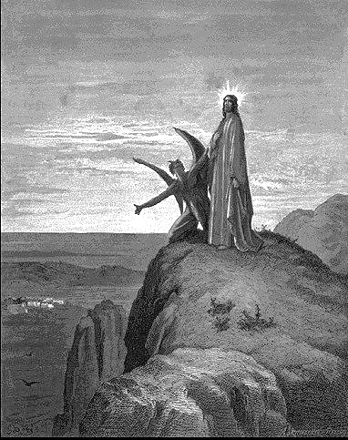
Painting by Gustav Dore
Reflection
As Christians, we are in our season of Lent. This is, I think, a unique season where we have a consistent Collect prayer throughout. It is prayed in addition to the collects for the day on the various Sundays, but it remains the spiritual heartbeat in the Church of England liturgical Lent. Its words are as follow:

Almighty and everlasting God, you hate nothing you have made and forgive the sins of all who are penitent: Create and make in us new and contrite hearts, that we, worthily lamenting our sins and acknowledging our wretchedness, may obtain of you, the God of all mercy, perfect remission and forgiveness; through Jesus Christ our Lord, who lives and reigns with you and the Holy Spirit, one God, for ever and ever. Amen.
It is a beautiful prayer, perhaps laden with the uncomfortable language of the Middle Ages, but none the less potent. I was struck last week by the tragic event that unfolded in Japan, while set against the backdrop of this prayer that forms another of my own focuses. The notion that God hates nothing that God has made is somehow benign in 'normal' time but takes on an entirely different character in the wake of the earthquake whose aftershocks still shake as I write this.

I was asked twice, quite reasonably, on Friday how God could allow such a thing to happen and for so many countless (and as yet uncounted) thousands to lose their lives. I have prayed about this at times in my own life, and in those times where our world seemed to be struck by yet another celestial thunderbolt. It became clear to me that God no more lets this happen to a living planet than I, as a parent, let my children fall and hurt themselves - yet it happens. Our planet is alive - it was made that way. For its life and ours, there needs to be certain 'behaviours' that our Earth experiences. It needs to move through space and it needs to 'breathe'. For these to not happen would mean that we could not and would not exist. These things I understand. These behaviours are the means by which our world is beautiful, that for many of us, a spring day can give way to a beautiful summer and a fruitful autumn. If Earth were a turgid rock, frozen and still, we would not be and we would be no more than a larger version of our moon - and yes, endlessly safe. Such a living planet demands all the shades of colour that life imply - the good and the bad.

I have no doubt at all that our loving God grieves every lost life in every natural disaster. I grieve the injuries that my children sustain but I cannot immobilise them into an inert and eternally safe environment. I would kill them in one way or another by wanting to keep them safe from any harm or the costs of living life fully. I pray for the people of Japan as well as those people in the places where life is thrown into chaos by the life our planet needs to live. what I cannot do, though, is blame God. God is not to blame, although I understand the need to wave our fists at heaven at times. In my frailty as a human being, if I can love my children enough and be a source of comfort when they feel pain, I have such hope that in the face of a global injury where so many have lost their lives and families are left in tatters, that God can be a source of light and hope for us all as he grieves with us. God hates nothing that God has made, and with such love, everything is not lost.

The Revd D Cloake, March 2011: extract of a sermon preached in Aylesbury following the Japanese Tsunami of 2011

More Questions for Discussion
- How do you understand God as Creator?
- How can we know God through Creation?
- How does this idea ride alongside the theories of science (evolution etc)?
- Can there be a meaningful relationship between science and religion in the Christian framework?

Week 2: … you forgive the sins of all who are penitent …

The Gathering
Leader Your Church makes glad in you, oh Christ, and cries aloud: You are our strength, O Lord, our refuge and our stronghold
All You are our strength, O Lord, our refuge and our stronghold
Leader Seeing you lifted upon the Cross, O Sun of righteousness, the Church stood still and cried aloud: Glory to your power, O Lord
All Glory to your power, O Lord
Silence is kept
Leader The Lord God almighty is our Creator.
All he loves us and tenderly cares for us.

Conversation Questions
- What do you think sin is? Consider giving examples of what you would call a sin, holding in mind the effect on the one(s) on the receiving end.
- Can or should all sins be regarded as equal?

God’s Word in Sacred Reading
- Read this passage from Paul’s letter to the Philippians silently, giving yourself permission to be present as one receiving Paul’s letter
- Philippi was a major city of Macedonia and a Roman colony. Paul is writing to the Church of Philippi from his prison cell, and the theme of joy emerges strongly despite Paul’s own sense of uncertainty about himself. This was a letter of thanks for gifts sent to Paul in prison, where he also sets out their situation in the light of the reality of Christ.
- One person from the group reads the passage aloud. Note a word or phrase that persists in your thoughts or catches your attention. Don’t question it – just acknowledge it!
- Another voice reads the passage as you ruminate on the word or phrase that caught your imagination. If your mind is called elsewhere, follow

Philippians 3.17-4.1
17Brothers and sisters, join in imitating me, and observe those who live according to the example you have in us. 18For many live as enemies of the cross of Christ; I have often told you of them, and now I tell you even with tears. 19Their end is destruction; their god is the belly; and their glory is in their shame; their minds are set on earthly things. 20But our citizenship is in heaven, and it is from there that we are expecting a Saviour, the Lord Jesus Christ. 21He will transform the body of our humiliation that it may be conformed to the body of his glory, by the power that also enables him to make all things subject to himself. 1Therefore, my brothers and sisters, whom I love and long for, my joy and crown, stand firm in the Lord in this way, my beloved.

Notes on the text:
- ‘Many live as enemies of the cross of Christ’ – is it presumed that Paul refers to those who cannot accept Paul’s own theology of the salvation of the Cross.
- ‘Our citizenship’ – Paul is referring to ultimate political loyalty and real homeland, contrasting the status of most Philippians as Roman citizens
- A crown was often awarded to the winners of races

Questions for Discussion
- Thinking about the context in which we find ourselves today, what is the importance of citizenship?
- Do you recall a time when you have been forgiven or have granted forgiveness to another? How did it feel?
- Who benefits from forgiveness?
- Is it possible to receive forgiveness without penitence (the action of feeling or showing sorrow and regret for having done wrong)?

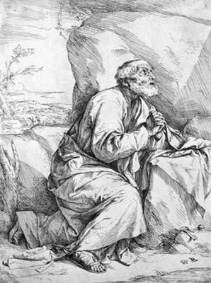
Jusepe de Ribera - St Peter in Penitence

Reflection
But God’s forgiveness is unconditional; it comes from a heart that does not demand anything for itself, a heart that is completely empty of self-seeking. It is this divine forgiveness that I have to practice in my daily life. It calls me to keep stepping over all my arguments that say forgiveness is unwise, unhealthy, and impractical. It challenges me to step over all my needs for gratitude and compliments. Finally, it demands of me that I step over that wounded part of my heart that feels hurt and wronged and that wants to stay in control and put a few conditions between me and the one whom I am asked to forgive.
Henri Nouwen
More Questions for Discussion
- Is it possible for a person to be ‘born evil’?
- How easily do you accept forgiveness? Can you accept it?
- Do you think it is easier to be penitent or easier to feel forgiven?
- How can we live with our brokenness?
Week 3: … you create and make in us new and contrite hearts …

The Gathering
Leader Your Church makes glad in you, oh Christ, and cries aloud: You are our strength, O Lord, our refuge and our stronghold
All You are our strength, O Lord, our refuge and our stronghold
Leader Seeing you lifted upon the Cross, O Sun of righteousness, the Church stood still and cried aloud: Glory to your power, O Lord
All Glory to your power, O Lord
Silence is kept
Leader The Lord God almighty is our Creator.
All he loves us and tenderly cares for us.

Conversation Questions
- How much of ‘yourself’ do you ascribe to your heart? How much do you ascribe to your head and brain?

God’s Word in Sacred Reading
- Read this passage from Luke’s Gospel silently, giving yourself permission to be present as an eyewitness in the scene
- How might it feel to be an occupied nation, with the Roman forces as occupiers? Consider how it might feel if those occupying forces desecrated your own church.
- One person from the group reads the passage aloud. Note a word or phrase that persists in your thoughts or catches your attention. Don’t question it – just acknowledge it!
- Another voice reads the passage as you ruminate on the word or phrase that caught your imagination. If your mind is called elsewhere, follow.

Luke 13.1-9
1There were some present who told Jesus about the Galileans whose blood Pilate had mingled with their sacrifices. 2He asked them, ‘Do you think that because these Galileans suffered in this way they were worse sinners than all other Galileans? 3No, I tell you; but unless you repent, you will all perish as they did. 4Or those eighteen who were killed when the tower of Siloam fell on them - do you think that they were worse offenders than all the others living in Jerusalem? 5No, I tell you; but unless you repent, you will all perish just as they did.’
6Then he told this parable: ‘A man had a fig tree planted in his vineyard; and he came looking for fruit on it and found none. 7So he said to the gardener, “See here! For three years I have come looking for fruit on this fig tree, and still I find none. Cut it down! Why should it be wasting the soil?” 8He replied, “Sir, let it alone for one more year, until I dig around it and put manure on it. 9If it bears fruit next year, well and good; but if not, you can cut it down.”’

Notes on the text:
- v1: The Galileans had been killed by the order of Pilate while sacrificing in the Temple in Jerusalem (this incident is only referred to here)
- v2: According to common Jewish belief, painful experiences were signs of God’s judgement. Jesus issued a call to repentance to avoid that catastrophe that would otherwise overtake his hearers

Questions for Discussion
- How do you understand the idea of God’s judgment? Is your understanding framed by negative connotations or can you see that judgment as a positive thing?
- What is the unusual agent for new growth in this gospel account? What might it teach us about our own lives and experiences?
- What does the Collect phrase “.. you create in us new and contrite hearts …’ mean for us as we seek to make better choices in our lives?

Reflection
He who alone searcheth the heart, alone can renew it unto holiness. To him then let us apply for the blessing. We have the strongest assurances that our application shall not be in vain. Hath he not given unto us "exceeding great and precious promises, that by these we might be partakers of the divine nature?" The promise of the new heart is the leading promise of the new covenant. "This shall be the covenant that I will make with the house of Israel after those days, saith the Lord, I will put my law in their inward parts, and write it in their hearts. A new heart also will I give you, and a new spirit will I put within you; and I will take away the stony heart out of your flesh, and I will give you an heart of flesh; and I will put my spirit within you, and cause you to walk in my statutes, and ye shall keep my judgments and do them." Encouraged by these gracious promises, let us pray with the penitents of old, "Turn thou us unto thee, O Lord, and we shall be turned." Let us cry out with the psalmist, "Create in us a clean heart, O God, and renew a right spirit within us." Let us come boldly unto the throne of grace, and in the language of our church intreat [sic] the Lord, who is the giver of all good things, to "write his laws in our hearts; to create and make in us new and contrite hearts; to grant that we, being regenerated and made his children by adoption and grace, may daily be renewed by his Holy Spirit, through our Lord Jesus Christ, who liveth and reigneth with the Father, and the same spirit, ever one God world without end." Amen.
Edward Cooper ‘Practical and Familiar Sermons’: 1815

More Questions for Discussion
- How might we understand the term ‘partake in the divine nature’?
- What one thing could you do this week to ‘partake in the divine nature’?
- How would you ‘rebuild’ yourself again this Lent?

Week 4: … we, worthily lament our sins and acknowledge our wretchedness …

The Gathering
Leader Your Church makes glad in you, oh Christ, and cries aloud: You are our strength, O Lord, our refuge and our stronghold
All You are our strength, O Lord, our refuge and our stronghold
Leader Seeing you lifted upon the Cross, O Sun of righteousness, the Church stood still and cried aloud: Glory to your power, O Lord
All Glory to your power, O Lord
Silence is kept
Leader The Lord God almighty is our Creator.
All he loves us and tenderly cares for us.

Conversation Questions
- How do you understand the idea of ‘worthy lamenting’? Is it easier to feel sinful or to believe in true forgiveness?
- Have you ever felt tempted to use the idea of your ‘wretchedness’ to absolve you from taking responsibility for something?

God’s Word in Sacred Reading
- Read this passage from the psalmist silently, giving yourself permission to be the one for whom the words are written
- In your mind, consider what your ‘transgression’ may have been?
- Note how forgiveness makes you feel
- One person from the group reads the passage aloud. Note a word or phrase that persists in your thoughts or catches your attention. Don’t question it – just acknowledge it!
- Another voice reads the passage as you ruminate on the word or phrase that caught your imagination. If your mind is called elsewhere, follow.

Psalm 32
1 Happy the one whose transgression is forgiven,
and whose sin is covered.
2 Happy the one to whom the Lord imputes no guilt,
and in whose spirit there is no guile.
3 For I held my tongue;
my bones wasted away
through my groaning all the day long.
4 Your hand was heavy upon me day and night;
my moisture was dried up like the drought in summer. Selah
5 Then I acknowledged my sin to you
and my iniquity I did not hide.
6 I said, ‘I will confess my transgressions to the Lord,’
and you forgave the guilt of my sin. Selah
7 Therefore let all the faithful make their prayers to you
in time of trouble;
in the great water flood, it shall not reach them.
8 You are a place for me to hide in;
you preserve me from trouble;
you surround me with songs of deliverance. Selah
9 ‘I will instruct you and teach you
in the way that you should go;
I will guide you with my eye.
10 ‘Be not like horse and mule which have no understanding;
whose mouths must be held with bit and bridle,
or else they will not stay near you.’
11 Great tribulations remain for the wicked,
but mercy embraces those who trust in the Lord.
12 Be glad, you righteous, and rejoice in the Lord;
shout for joy, all who are true of heart.

Notes on the text:
- This is a thanksgiving psalm found within the seven Penitential Psalms used by Christians – and assumes that human affliction is the punishment of a just God. This affliction is believed to be transformed by ‘confession’ (v5)
- ‘Selah’ is a term of unknown meaning found only in the Psalms (and one other place) – but likely to be a Hebrew musical term to separate subunits.
- vv2-5 the psalmist’s silence (lack of confession) brought on illness whilst acknowledgement brought healing and forgiveness.

Questions for Discussion
- Consider a contemporary translation for arcane terms like ‘wretchedness’ or ‘transgression’
- Have you ever made your individual confession (as distinct from the corporate confession that is made within Eucharist services)?
- What, if any, difference could it make to you to articulate your ‘transgressions’ before God?

Reflection

Do you serve God or your feelings?

Now, that may sound like an odd question for a believer, but really, it isn't. Let me put it this way... When you ask God to forgive you, do you accept His forgiveness right away or do you waste time feeling guilty?

So many Christians struggle with guilt and condemnation. They're trying to pay God back for what they did wrong when Jesus already made it right.

God's unconditional love is a very difficult concept for people to accept because, in the world, there's always payment for everything we receive. It's just how things work here. But God is not like people! We need to learn that whether or not we feel forgiven, we're forgiven.

Feelings of guilt and condemnation are a huge problem in the Church, but I want you to understand that’s what they are—feelings.

If you really know God's Word, no matter how you feel, you can speak scriptures over your life and pretty soon your feelings have lost their authority.
For instance, 1 John 1:9 says that if we repent and confess our sins, God is faithful to forgive us. You need to take hold of that.

The next time you ask God to forgive you and then feel guilty afterward, open your mouth and say, "God forgave me." Quote 1 John 1:9 or use another scripture but say it out loud. There is power in the tongue!

Praying and declaring Scripture out loud not only helps to renew your mind, it helps you stand firm, and it certainly puts the devil in his place.

The devil will try to make us feel guilty even when we didn't do anything wrong. So we need to confess our sins until everything is out in the open and told, and then get dressed in our spiritual armour so we can firmly stand our ground.

When it comes right down to it, we just want to be loved unconditionally and accepted for who we are. We don't want to have to pretend or perform. We just want to be accepted and loved. And God offers that to every single one of us.
None of us can earn God's love. But in order to receive God's love we need to first believe that He loves us.

If you have trouble believing God in this area, don't just put up with it and wish that you felt better. Study the love of God. Read books about it. Listen to teachings on love. Start talking about it.

Say, "If anybody can have God's love, I'm going to have it. If anybody can be free, I'm going to be free. If anybody can be happy, I'm going to be happy. If anyone can have peace, it's going to be me. If anybody can be used by God, I can be used by God. If anyone can get over their broken past, I will."
Don't give in to your emotions—minister to them. Manage them. Remember that every day you're in Christ, you're a new person.
Joyce Meyer

More Questions for Discussion

- Why is the Gloria in Excelsis normally (except during Lend and Advent) sung after the Prayers of Penitence? When was the last time you focussed on the words and their meaning? Why is this prayer more typically sung wherever possible?
- How could you ‘minister to’ your emotions?
- How could mental illness play an important part in this? How could you help someone struggling with depression in this effort to worthily lament?
Week 5: … we may receive from you, the God of all mercy

The Gathering
Leader Your Church makes glad in you, oh Christ, and cries aloud: You are our strength, O Lord, our refuge and our stronghold
All You are our strength, O Lord, our refuge and our stronghold
Leader Seeing you lifted upon the Cross, O Sun of righteousness, the Church stood still and cried aloud: Glory to your power, O Lord
All Glory to your power, O Lord
Silence is kept
Leader The Lord God almighty is our Creator.
All he loves us and tenderly cares for us.

Conversation Questions
- What is the most precious gift that you have ever received from another person? What made it so precious / important / valued?
- What do you wish for in this life?

God’s Word in Sacred Reading
- Read this passage from the psalmist silently, ‘singing’ this song as pilgrim travelling to the sacred and mighty City of Jerusalem
- What purpose might lay behind your pilgrimage? What has it cost you to make the journey?
- One person from the group reads the passage aloud. Note a word or phrase that persists in your thoughts or catches your attention. Don’t question it – just acknowledge it!
- Another voice reads the passage as you ruminate on the word or phrase that caught your imagination. If your mind is called elsewhere, follow.

Psalm 126
1 When the Lord restored the fortunes of Zion,
then were we like those who dream.
2 Then was our mouth filled with laughter
and our tongue with songs of joy.
3 Then said they among the nations,
‘The Lord has done great things for them.’
4 The Lord has indeed done great things for us,
and therefore we rejoiced.
5 Restore again our fortunes, O Lord,
as the river beds of the desert.
6 Those who sow in tears
shall reap with songs of joy.
7 Those who go out weeping, bearing the seed,
will come back with shouts of joy,
bearing their sheaves with them.

Notes on the text:
- This psalm is from a collection is the Psalter called the ‘ascent psalms’ – and are given the common heading ‘A Song of Ascents’ (maybe used by pilgrims visiting Jerusalem)
- This thanksgiving psalm may reflect the sixth century BCE return from exile, regarded as a new Exodus
- vv 4-6 petitions for winter rains – even given the arid nature of the Negeb in the south – and a good harvest after the return to the land
- This is also used as a metaphor for national restoration

Questions for Discussion
- What small changes could we make in our lives that would allow us to more meaningfully ‘receive’ from God?
- When was the last time that you took a pilgrimage or a retreat? What benefits might there be in such pastimes?

Reflection
We receive from the Lord in the same way that people in the Bible received from the Lord—whether it is salvation, healing, the baptism in the Holy Spirit, or some other gift God has provided. We receive by faith.

This fact is emphasized in James 1:5–7, which tells us what to do if we are lacking something in our life. The Apostle James said that we are to ask of God, but instructs us to ask in faith in order to receive. James begins this passage talking about receiving wisdom, but he ends the passage talking about receiving anything. Well, healing, or anything else the Word promises, is certainly included in “anything,” because “anything” includes all things!

Does “anything” also include the baptism in the Holy Spirit? Certainly, it does. And a person receives the baptism in the Holy Spirit the same way he or she receives anything else from God—by faith.

The Bible tells us how the Apostle Paul was able to minister the baptism in the Holy Spirit and to work miracles among the people. It was “…by the hearing of faith.” But if we’re not careful, we’ll think, Well, yes, but Paul was an apostle, and God endowed the apostles with special power. If we had their same power and anointing, we could do the things they did. But Galatians 3:5 [tells] us exactly how Paul ministered! He did it by the hearing of faith! In other words, those people received from God through Paul’s ministry by their hearing faith preached to them.

We are studying how to receive from God. We know … that we receive by faith, or by believing. We also know from these verses that “all things” are possible to those who believe. Well, “all things” means anything, doesn’t it?

We know we must believe, but where does this believing take place? The verses we’ve studied so far show us that believing takes place in our heart, not in our head. I want us to study something further that the Word of God has to say about the heart. We’re told to believe with our heart, but what is the heart?

When the Bible talks about believing with our heart, it isn’t talking about believing with the physical organ that pumps blood throughout our body. It’s talking about believing with the inward person, or our spirit.

Faith is of our heart, our spirit. In other words, you believe on the inside. And what you believe on the inside is manifested on the outside. God starts working on the inside of a person and works to the outside. For example, healing doesn’t start on the outside—it starts with your believing in your heart (on the inside). When you pray, you believe that you receive, and then you shall have the healing you desire (on the outside).
Kenneth Hagin
More Questions for Discussion

- If we understand the heart as the place where we receive God, how might we improve the fitness / effectiveness of that ‘muscle’?
- Each week at church we are offered a sermon by varying people. How might we more meaningfully engage with the preacher’s words after the service is concluded?
- What area of church life or your own spiritual life allows you to receive from God most fully?
- How could church life or your own spiritual life be adapted to encourage a greater sense of receiving from God?

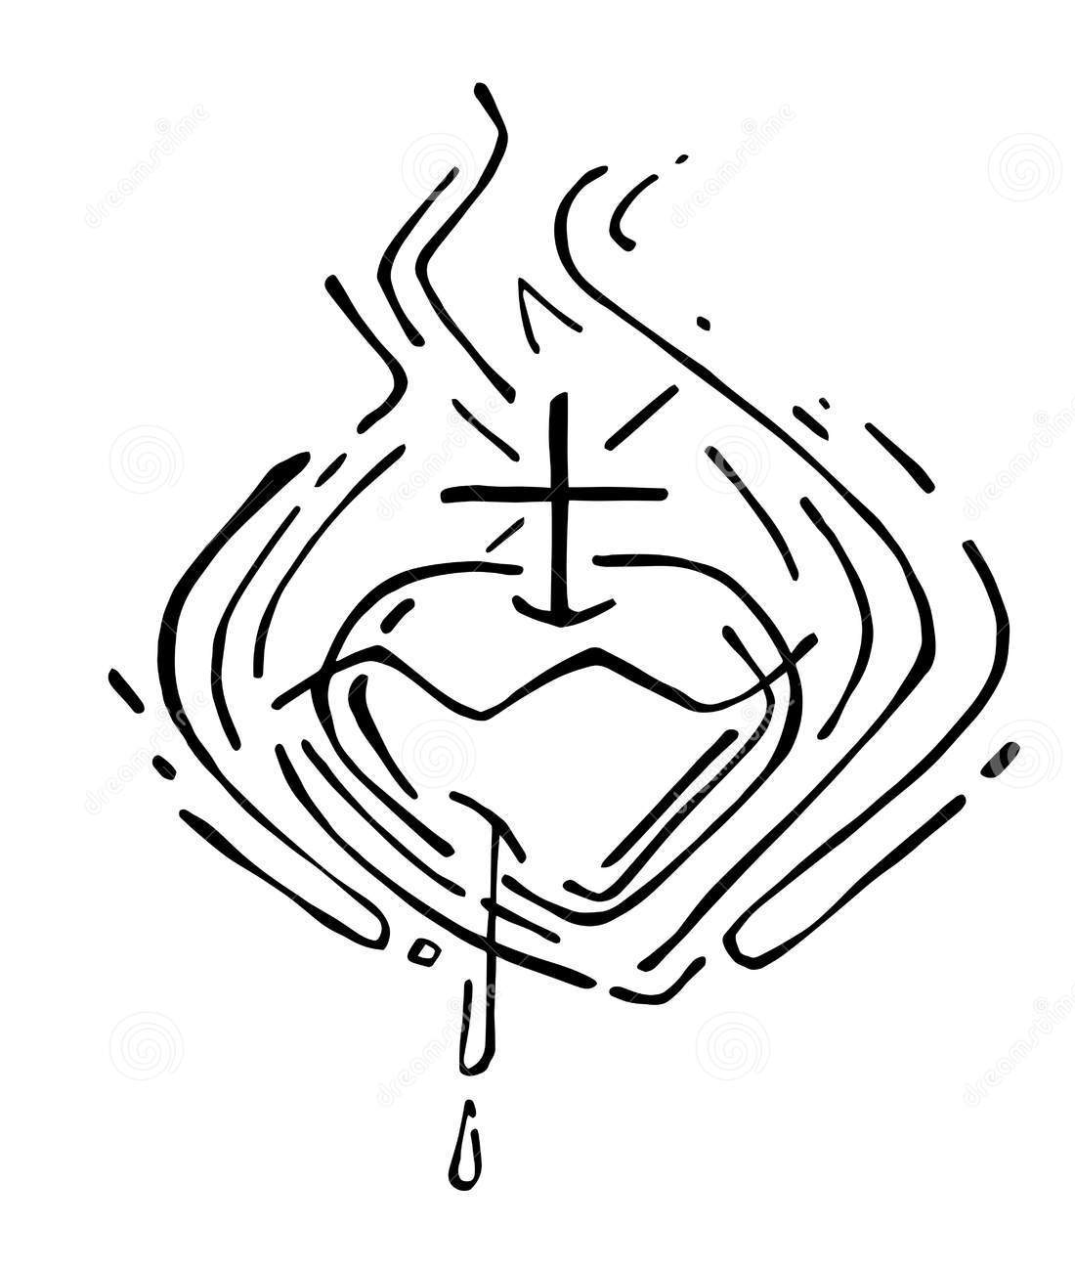

Week 6: …perfect remission and forgiveness …

The Gathering
Leader Your Church makes glad in you, oh Christ, and cries aloud: You are our strength, O Lord, our refuge and our stronghold
All You are our strength, O Lord, our refuge and our stronghold
Leader Seeing you lifted upon the Cross, O Sun of righteousness, the Church stood still and cried aloud: Glory to your power, O Lord
All Glory to your power, O Lord
Silence is kept
Leader The Lord God almighty is our Creator.
All he loves us and tenderly cares for us.

Conversation Question
- What does the word ‘remission’ mean to you? What feelings does it evoke within you?

God’s Word in Sacred Reading
- Read this passage from Luke’s Gospel silently, giving yourself permission to be present as an eyewitness in the scene
- In your mind, examine your feelings as you listen to Jesus story-telling. What questions does his parable answer, or indeed create in your mind?
- One person from the group reads the passage aloud. Note a word or phrase that persists in your thoughts or catches your attention. Don’t question it – just acknowledge it!
- Another voice reads the passage as you ruminate on the word or phrase that caught your imagination. If your mind is called elsewhere, follow.

Luke 20.9-19
9He began to tell the people this parable: ‘A man planted a vineyard, and leased it to tenants, and went to another country for a long time. 10When the season came, he sent a slave to the tenants in order that they might give him his share of the produce of the vineyard; but the tenants beat him and sent him away empty-handed. 11Next he sent another slave; that one also they beat and insulted and sent away empty-handed. 12And he sent yet a third; this one also they wounded and threw out. 13Then the owner of the vineyard said, “What shall I do? I will send my beloved son; perhaps they will respect him.” 14But when the tenants saw him, they discussed it among themselves and said, “This is the heir; let us kill him so that the inheritance may be ours.” 15So they threw him out of the vineyard and killed him. What then will the owner of the vineyard do to them? 16He will come and destroy those tenants and give the vineyard to others.’ When they heard this, they said, ‘Heaven forbid!’ 17But he looked at them and said, ‘What then does this text mean:
“The stone that the builders rejected
has become the cornerstone”?
18Everyone who falls on that stone will be broken to pieces; and it will crush anyone on whom it falls.’ 19When the scribes and chief priests realized that he had told this parable against them, they wanted to lay hands on him at that very hour, but they feared the people.

Notes on the text:
- The use of the term ‘beloved’ identifies the son with Jesus
- The murder of the son outside the vineyard may reflect Jesus’s crucifixion outside the city of Jerusalem

Questions for Discussion
- Why do we feel jealousy? What emotions are in play?
- What ‘kingdom imagery’ is contained within this pericope ? ? What might the significance be of Jesus’s choice of vineyard in this parable?
- What is the long-term effect of jealousy upon a person?
- Is there a cure for jealousy?

Reflection
'Remission' is a word that Christians use often, and mostly without any thought. We pray for the 'remission of our sins', and rightly so - but do we really know we mean? For those of you about to bounce around in your seats yelling "yes, Farv, of course I do", then I congratulate you, for I thought I knew too, but didn't really in truth.

… I pondered the meaning of that word 'remission'. Like so many things, it is bound up in context. For example, speak of 'remission' to a person winning a fight with cancer and we have a taste of the word at its most powerfully wonderful. 'Remission' can also refer to the making of a payment - and here we have a very clear indicator of the payment of the Cross. 'Remission' can also refer to surrender and for me, at least, directs my thoughts to the Garden of Gethsemane. Again, 'remission' tells us of being discharged from debt, and here we wander into the territory of redemption which owes its meaning to related ideas.

So, we have a number of very broad labels to work with here. And there was us thinking we knew what 'remission' was when applied to our sins. We have cure, payment, discharge, abatement, surrender - such a loaded and potent word that easily falls from our tongues in prayer. What is also easy to miss is that we ask God to grant this to us - that it demands no action from us (though we are, of course, called to penitence earlier in the Ash Wednesday Collect). I wonder how many people, when labouring under the terrible shadow of a cancer, have prayed earnestly to be in a state of remission. Whilst I have only had the merest scare in that regard, even then I got a flavour of the depth and anguish in that cry. To be granted remission in that case is nothing less that been granted a new life in its entirety. So it is with our cry from remission of sin. It is no less a life-or-death pleading.
'Remission', in all the definitions that I have seen and read talk about a one-direction process. Something was there and then it was either in retreat or it wasn't there at all. Re-mission says more to me than that. It talks about our duty, as Christians, not just to receive 'perfect remission', but to take that out to the world. Or another way, when we receive perfect remission from God, we receive a new opportunity to re-mission in the world in which we live. In the word, there is a mandate, an opportunity to engage with 'mitto' [Gk] - to be sent out. When we pray for 'perfect remission' of our sins, we pray to receive something. What is clear to me is the implicit call then to share that with the world that may not know about this perfect gift of grace.

The Revd David Cloake, from a blog post April 2011

More Questions for Discussion
- ‘Remission’ is often translated into ‘forgiveness’ in modern liturgical texts. How are these terms similar and how are they distinctive?
- Many of us have either known someone been someone who has been told that their cancer is in remission. What emotion did that bring about?

Closing Thoughts as Lent closes
- What do we see differently as a result of this course of study?
- How has Lent been? Did you stick with your Lenten ‘resolutions’?
- How will this Lent draw you more closely into the death and resurrection of Jesus Christ (and thereby into your own baptism)?

The Katavasia of Canticle V from the Lenten Triodion, the Greek Orthodox Church, 1984
The Katavasia of Canticle IV from the Lenten Triodion, the Greek Orthodox Church, 1984
A ‘Pericope’ is a short extract from a text

