The Parish Church of
Saint PETER & Saint PAUL
Teddington

April 2020-April 2021

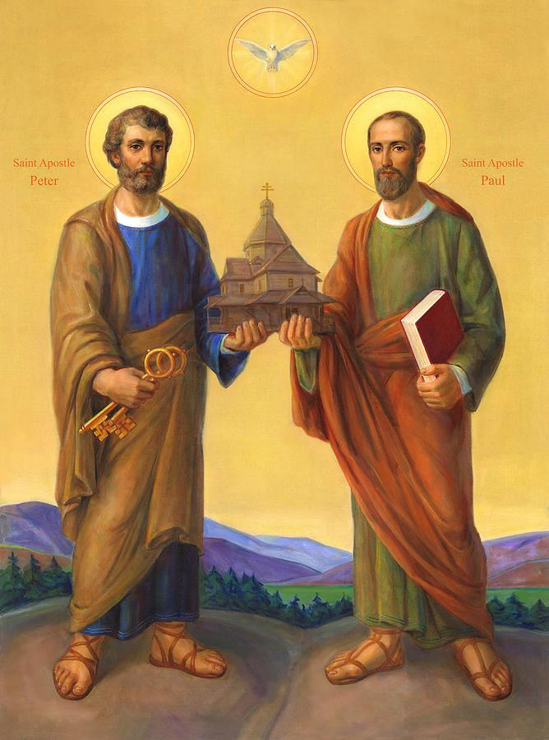

Parochial Church Council 2020-2021
Parish Priest:
Revd Joe Moffatt – Priest-in-Charge

Churchwardens:
Clare Rider
Deborah Cardamone
Deputy Churchwarden: Denis Wheeler

Honorary Secretary:
Jennifer Britten

Honorary Treasurer:
Kornelia Beardsworth

Safeguarding Officer:
Andrew Pepperell

Children’s Champion:
Deborah Cardamone

Deanery Synod Representative:
Vacancy

Electoral Roll Officer:
Clare Rider

Foundation Governor:
Will Bulkeley

Other PCC Members:
Rupert Abbott
Louisa Ellisdon
Jenny Grant
Judith Good
Bryony Pemberton
Rachel Woolstone
Jean Howard

Changes to the Parish
Last year’s annual report recorded the decision taken at Diocesan level in 2019 that St Peter and St Paul cease to exist as a separate parish from 2021. A draft Pastoral Scheme has now been drawn up and circulated, proposing that:
(i) the parish church of St Peter and St Paul, Teddington and its annexed land to be transferred to the parish of Teddington St Mary with St Alban the Martyr;

(ii) the dissolution of the benefice of Saint Peter and St Paul, Teddington and for its parsonage house to be transferred to the London Diocesan Fund for diocesan purposes, together with the dissolution of its constituent parish and transferring its area to the parishes of Teddington St Mary with St Alban the Martyr; and St Michael and St George, Fulwell;
(iii) the creation of the extra-parochial place known as “The Teddington Mission Hub”, its area to comprise the church building of St Peter and St Paul, Teddington (now a chapel of ease) and its annexed land in the diocese of London.
The main effects of the scheme will be two-fold:
The geographical parish
This will be allocated to the two adjacent parishes of St Mary with St Alban and St Michael, Fulwell, after the formal diocesan-led consultation process, as required for any pastoral reorganisation. There will not be many practical implications other than residential requirements for weddings/banns. St Mary’s and St Peter’s School admissions policy will not be affected since families in the combined area of St Mary with St Alban, St Peter and St Paul and St Michael are given the same priority if attending any one of those churches. The pastoral reorganisation will only affect the internal boundaries in this area.
The Church building
The Church building (including the Hall and all the auxiliary rooms) will be established as an Extra- Parochial Place, known as the Teddington Mission Hub. This means that it will be lifted out of the parish system and not come under the jurisdiction of the parish in which it is situate. Instead, it will have its own governance body, a Board of Trustees, which will be directly accountable to the Bishop.
To prepare for the transition, the Diocese has established the Teddington Mission Hub as a Charitable Independent Organisation (CIO), a legal entity with a Board of Trustees, which has obtained registered charity status. The Board is chaired by Jonathan Rust, Director of Mission for the Kensington Area of the Diocese of London.
On the dissolution of the parish, the parish’s remaining financial assets will be transferred to the Teddington Mission Hub, to be used to support the maintenance of the building and amenities. The church plate, ornaments, office equipment and other fixtures and fittings will also be transferred to the Teddington Mission Hub.

Electoral Roll
The Electoral Roll of St Peter and St Paul, Teddington, stands at 38, 22 living within the parish boundary and 16 outside. The Electoral Roll Officer is sad to report the death of Jean Vatcher, a long-term parishioner, who died on 15 February 2021 at the age of 92.

Safeguarding
The PCC has complied with the duty to have “due regard” to the House of Bishops’ guidance in relation to safeguarding. A resolution was passed in relation to the reporting of safeguarding serious incidents to the Charity Commission; this delegated such reporting to the General Secretary of the London Diocesan Fund. All safeguarding concerns are always reported to the Diocesan Safeguarding Advisors.
An annual Safeguarding Self Audit was carried out in 2020 and an action plan put in place.

Fabric

The following works have been attended to over the past year:
Fire Certificate - our Contractor, A1 Fire Protection, continues to carry out regular inspections and a full service of our safety equipment.
Church Hall - the Hall floor was deep-cleaned and re-treated on 16 April 2021
Boiler – The heating and hot-water supply were turned off during the first shut-down of the building because of the Covid-19. Before they were restored, Jim Lawrence spent a day cleaning and chlorinating the entire water supply to protect it against legionnaire’s disease.
Utilities – Both gas and electricity accounts have now been transferred to SSE on a dual-fuel contract.
Roof – The PCC, having taken professional advice, resolved that the flat roof over the hall, entrance hall and ancillary rooms has reached the end of its life and needs to be replaced, and that the gulleys between the roof sections need to be stripped and relined. The roof materials (over 40 years old) are no longer fit for purpose, resulting in water ingress into the church building and a considerable build-up of water on the roof which cannot drain. There is a danger of further, more extensive, leaks and, at worst, ceiling collapse. At an extraordinary meeting on 18 February 2021, the PCC authorised payment from its investment and legacy funds towards the roof replacement, and approved an application for a grant of £10,000 and an interest-free loan of £10,000 from the Kensington Area Council towards the remainder of the cost. This application was successful.

The Teddington Mission Hub Board of Trustees confirmed its support for the roof replacement and has agreed to take on responsibility for commissioning and managing the project. In the absence of a QI Architect, the Board has referred the scheme and schedule of works to members of the Diocesan Advisory Council for their approval prior to commissioning the work. A faculty is not required for a like-for-like roof replacement and the Archdeacon has already indicated his support in principle for the roof refurbishment. The TMH Trustees will be named as clients on the building contract and have undertaken to repay the loan to the Kensington Area Council over a 5-year period.

Flat 4 windows – After much delay, replacement windows were installed on 3-4 March 2021.
Partition wall – The partition between the church and hall has been serviced and is now in good working order.
Church chairs - Permission has been obtained from the Archdeacon to dispose of the 30 Church chairs which are currently stacked up in the cupboard formerly used by the Montessori nursery school. The chairs will be offered for sale via the internet or donated to an appropriate organisation.

Sunday Services and Mission

Following the departure of Azariah France-Williams in February 2020, the PCC of St Peter and St Paul took the decision to stop running regular Sunday services at St Peter and St Paul and to merge our worshipping congregation with that of St Mary with St Alban. A very moving ‘Final Service’ was held at SPSP in March 2020, followed by a ‘Coming Together’ service at SMwSA the following week. During the subsequent Covid-19 lockdown our integration continued online and in other ways. In August 2020 the 9am Sunday family service moved from SMwSA to SPSP to assist with implementing Covid-19 social distancing measures. A track and trace system was introduced and seats arranged in household groups. After a further, Covid-related interruption to church worship from December 2020 to early April 2021, the 9am service resumed at SPSP on Easter Sunday.
The SPSP church building also accommodates an exciting Sports Ministry (Activate) and a Community Café, both of which have long been in the joint parishes’ Mission Action Plan. Their reports appear below.

Activate Sports Ministry

Aims
Activate is a pioneering sports ministry programme to enhance community, wellbeing and faith through sporting activity. It is a pilot project of the Hampton Deanery of the Diocese of London, with a long-term vision of replication and roll out across other Deaneries and Dioceses.

We seek to engage with all ages, abilities and people, to create fun, friendly (sometimes competitive) activity with a community focused approach to help people get or maintain being active, while creating local relationships that encourage inclusion and support.

Working in collaboration with the wider community partners including our schools, community groups and parks, and taking an evidence-based and place-based approach, we aim to use our buildings, staff and volunteers to:
- Promote wellbeing for all.
- Connect communities – build partnerships, share resources, strengthen bonds.
- Provide Chaplaincy and support for sport club members, teams, and families.
- Enable faith ‘where you are’ and help people to grow fitter together physically and spiritually.

The Story So Far
Activate began life in July 2020 with the appointment of Chris Kennedy as its Sports Minister and is based at St Peter and St Paul’s Church in Teddington, where the church building provides a facility for the indoor activities and a home for the ministry. Chris is supported by a small team, which consists of an Operations Manager and two Interns, and there are plans to appoint a Youth Worker in the coming months.

Of course, starting a sporting project during a pandemic has had it challenges. With initial activities severely curtailed, our programme has had to keep up with the changing tiers and lockdowns that we have found ourselves in. However, we have been able to deliver the following:
- Online gentle chair-based exercises – before lockdown we had started to work with the local social prescribing teams in Teddington, and had devised a series of sessions for their clients. To continue these, and to ensure all members of the community could access them, we moved online, providing a mix of live Zoom classes, along with sessions on our YouTube channel that people could do in their own time. With lockdown easing we will run these sessions in person (Soup + Stretch) as well as continuing to provide the sessions on Zoom and recorded versions on our YouTube channel.
- The Wellbeing Journey course - wellbeing has never been more relevant or important, so with this in mind Activate have started to run a course which helps to address the challenges of our times. It is a series based around seven key areas of wellbeing – the wellbeing mindset, physical, emotional, spiritual, relational, financial, and vocational – to help people to discover a balance in life. We have run these online but plan to continue running more of these courses in person when we are able to.
- Support of local charities including Surplus to Supper and Ruils, in the distribution of food for their food banks.

Post Lockdown Plans
Now, with the successful vaccination rollout, we can begin to think about a programme of activities where people can come together and enjoy getting active. In the coming months, as well as continuing the work we started during the pandemic, we will be putting on the following activities:

- Running and cycling groups, to encourage people of all abilities to take up exercise.
- The creation of a Youth Hub at St Peter and St Paul’s. More and more people are suffering with their mental health, and this includes many young people. We are well placed at Activate to support them and we have forged relationships with Richmond Borough’s Achieving for Children team, who are very keen to work alongside us on this youth project.
- Sport based youth events, school sport and after-school and school holiday clubs.
- Chaplaincy to local sports clubs (rugby, football, cricket, and hockey), their families, volunteers, and staff.
- School PE assistance collaborating with Kick at St Mary and St Peter’s in Teddington and St Richard’s in Hanworth.

In the last few months Activate has become a CIO and we have been successful in gaining some funding from several funds, namely The National Lottery Community Fund, One Richmond, The National Lottery Local Connections Fund and Active Richmond Local Area Fund. This much needed funding will primarily support us in our plans for youth provision and the creation of our Youth Hub. We hope to be able to support young people so that they are more comfortable talking about mental health and accessing support, have greater confidence in physical activity and as such experience improved physical as well as mental wellbeing.

Going forward, we feel that we have a programme of activities which is robust and one that we will be able to continue to deliver, even if Covid restrictions change. It reaches more people than we had predicted in our first year due to the accelerated way we now use technology. Of course, physical activities are what we really want to provide, but the addition of online content is a valuable plus.

We will continue to promote what we are doing through our local and church communities, our social media channels, and our website, all the while not forgetting our core values - activating community through wellbeing that invigorates faith.

Community Café
Monday 5 October 2020 saw the launch of the Teddington Community Café, following many months of preparation. Initiated by members of St Peter and St Paul and St Mary with St Alban as a practical way to promote the mental health and well-being of local residents, the project has been developed in partnership with NHS Primary Care Networks (PCNs) and two of our neighbouring charities, Ruils and Richmond Aid. The café aims to offer a welcoming space with a friendly, calm and positive atmosphere, and with many volunteers on hand to chat over coffee and cake. It should be of particular benefit to those feeling socially isolated at this time.

In undertaking background research, the café team became aware of the large number of local organisations which offer interesting activities and valuable services. The café, with its central location at St Peter and St Paul’s Church, on the corner of Church Road and Broad Street, is an ideal place to signpost these. It also provides a convenient venue for social prescribers to meet clients and to offer healthcare advice.

After a very successful start, endorsed by customers who appreciated the warm welcome, the conversation, quality hot and cold drinks and delicious cakes, the café was forced to close at the beginning of December 2020 due to the increased Covid-19 restrictions. It will reopen weekly on Mondays, from 1.30pm to 4.30pm, from 17 May 2021.

Hampton Deanery Synod report for 2020-2021 by Sue Stevens
Due to Covid restrictions meetings there were only two meetings, both held on Zoom. Both were chaired by Garth Watkins, and led by the Area Dean, the Revd Tim Garrett.
The November meeting was addressed by Bishop Graham who updated people about his 2030 Vision. This was followed by breakouts into smaller groups to discuss possibilities for individual parishes. There was a focus on reaching out to groups who have not been traditionally part of church communities.
The February meeting introduced three new incumbents and, after business matters were settled, attendees listened to an interesting presentation by the Revd Canon Miles Baker, Kensington’s Area Director of Ministry, who spoke about ‘The future of Vocations’. The position in the Kensington diocese is positive, with 50 curates, 63 ordinands in training, and 37 potential candidates on discernment. The discernment process is changing to detect candidates’ potential rather than evidence of experience.
This was followed by the Revd Chris Kennedy giving an update on the progress of the Activate project. In spite of lockdown Chris was already working with 2 schools and 7 sports clubs, reaching out in innovative ways.

St Mary’s and St Peter’s School report for 2020-2021 by Malcolm Eady
- Response to the Covid pandemic
The school has coped well with the upheavals caused by the Covid Pandemic. The school was divided into year group bubbles. There was a management focus on keeping the bubbles separate and so limiting the effects of any Covid cases. Out of a staff of seventy, ten contracted Covid. During the lock downs about 90 children came into school out of 610.

Last spring (2020) the school had already started to plan for online learning before the lockdown was announced, so it was able to quickly implement a programme using Google Classroom. For most children the lockdown lasted from March until the end of the summer term. Live meetings with their teachers were via Google Meet.
During the autumn term the children were in school but in their year bubbles. At Christmas the staff organised a Nativity story trail around the building for all the children to follow and enjoy as well as each year group recording a celebration for their families to view online, as there were no “on-stage” Christmas productions.
During the second Lockdown (from January to March 2021) the online provision was improved with a concentration on the academic and wellbeing provision. Below are just some of the activities and support packages which were provided:
- Careful identification of vulnerable children/EHCP/SEND and bespoke support for these children and families; (EHCP - education, health and care plan, SEND - Special educational needs and disabilities)
- Daily class meetings with teachers and lesson explanations;
- Group interventions;
- SEND interventions;
- SEND online meets with children;
- Online marking;
- Home delivery of laptops and school resources;
- Weekly paper lesson packs;
- Individualised book bags and comprehension sheets;
- Reminder phone calls for children who missed meetings;
- Instructional videos from teachers and TAs (Teaching assistants);
- Visits to families who weren’t engaging;
- ELSA (emotional literacy support assistants) phone calls (meeting in person if the child is in a school bubble);
- In- school sessions for new SMSP children;
- Where necessary time in school to set children up on Google Classroom;
- Ad-hoc time in school for children e.g. parents with medical appointments;
- Sports challenges;
- Daily Head/ clergy/ music assemblies;
- Music lessons;
- Extra- curricular activities;
- Additional Google Classroom rooms for differentiation of work by ability;
- Learning style and individual work and interventions for children with EHCPs.
This comprehensive list is just to show how much the school, during the lockdown periods, has had to change the way it delivers things and some of the new activities which it has had to provide.
- Governor roles
The Rev. Mary Hawes is the chair of Governors and the Rev. Joe Moffatt is also on the governing board and so is the Rev. Simon Pedley from St Michael’s, Fulwell.
Our meetings have been online since March 2020. We have had our normal range of committee meetings, but we have not been able to hold our annual Governor visit to all the classes in the school and our meeting with the school council.
- Key issues
The key issue this year is the same as it has been for a number of years – finance.
When compared on a benchmarking exercise with similar schools in outer London, we received the lowest in grant funding, but when total income per pupil is considered, we are about at an average level. We struggle every year to produce a balanced budget. Unlike some schools we have not had to reduce staff levels. We are noticing a trend of families moving away from London, as parents can work online. There has always been a small number of children who move away in years 4 & 6 to go into private education. Every child leaving makes it harder to produce a balanced budget.
We are extremely gratefully to fund raising work of the Friends of the school, who help keep the school very well equipped.
In January the Head Teacher Mr Logan informed the governors that he would retire at the end of the summer term. Four years ago, Mr Logan tried to ‘retire’, but the governors were unable to appoint a replacement, so he returned to the role three days a week, with Mrs Bateman taking the role of Acting Head Teacher for two days a week. He has indicated that this time there will be no comeback. A recruitment process is therefore under way and it is hoped to hold interviews later this month.

