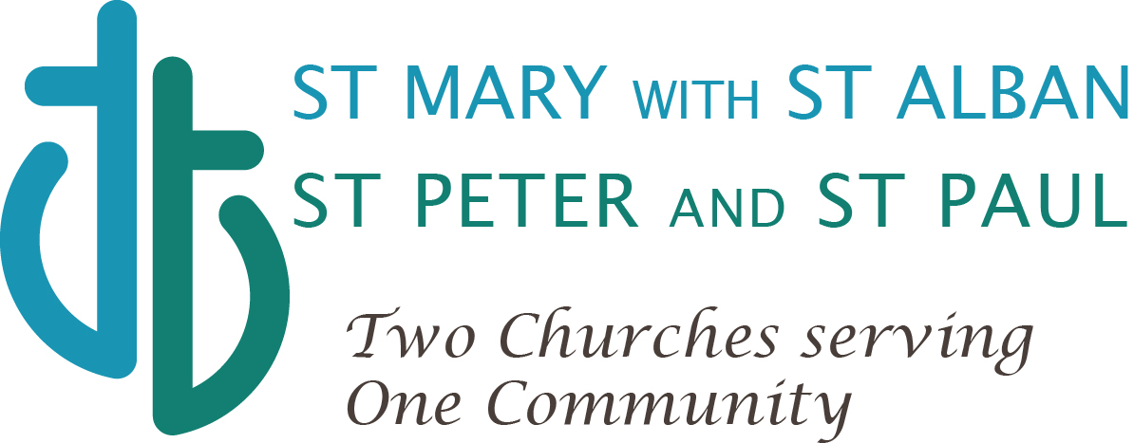
www.teddingtonparish.org

Job Description:
Assistant Youth Leader and Administrator
(Part-time – 16 hours per month)

We are two churches (known as Teddington Parish) with one vision: “growing faith and friendship for all.” Part of this vision is to offer a fortnightly youth group, enabling young people to grow in faith and friendship. We are seeking a part-time Assistant Youth Leader and Administrator to help run this activity.

We currently run two groups: Younger Youth (6-7.15pm) for young people in Years 6-7 and Older Youth (7.15-8.30pm) for Years 8-9. These groups meet on the 1st, 3rd and 5th Sundays of the month. There is usually an outing once a term and a residential weekend in May organised by the diocese.

Responsibilities

- Assist the clergy in leading both Younger Youth and Older Youth on 1st, 3rd and 5th Sundays of the month
- Supervise the young people and ensure general health & safety and rules of conduct
- Set up and tidy up for each session
- Build a rapport with young people and listen to their concerns
- Facilitate and participate in games, activities and discussions with young people
- Administration support, e.g. sending out emails to the group, planning rotas, admin for events and risk assessments

Required Skills and Attributes

- Sympathetic to the Christian faith,
- Able to work as part of a team
- Can demonstrate leadership skills
- Able to build rapport and inspire confidence with young people
- Committed to the faith development of the young people
- Competent I.T. and administration skills
- Practical and adaptable
- Valid DBS Check

Hours of work:

Total: 16 per month as detailed:

- Termly programme planning, volunteer rota, event planning – 12 hours per term, 3 hours per month
- Pre-session planning/prep – 4 hours per month
- Pre-session communication with families and volunteers – 2 hours per month
- Session work – 7 hours per month

Remuneration:

£160 per month - paid monthly in arrears. (This equates to £10.00 per hour for a 16 hour month and £1,920.00 per annum).
Additional hours will be paid at the rate of £10.00 per hour.

Applications:

Please contact Joe Moffatt for an initial conversation and further information:
The Revd Joe Moffatt, Vicar
vicar@stmarywithstalban.org
07742 6185276

Applications to be made by sending CV, covering letter and names of two referees to Joe Moffatt by September 14th 2018.

